2016 - 2017
Building Strong Collaborative Efforts
Midwest Counterdrug Training Center
Instructor: Greg Pliler

Contents
Learning Objectives 3
Introductions 4
Actionable Item Worksheet 5
Coalition defined 6
Levels of Collaboration 7
Lead Agencies 10
Key Individuals and Organizations 11
12 Sectors 12
Recruiting and Retaining Members 13
Assessing Needs 13
Retaining Members 15
Retaining Members Activity 15
New Member Packets 16
Talking to Potential New Members 17
Developing Structures and Rules 18
Examples of Coalition Organization Charts 19
By-laws 21
Job Descriptions 22
Engaging Community Members 23

Learning Objectives
- Identifying the need for collaboration

- Identifying a lead agency

- Identifying key individuals and organizations

- Recruiting & retaining members

- Developing structure and rules to promote success

- Engaging Community Members

Introductions
Name

Organization

Number of years in prevention & number of years working with coalitions

_______ /________

Define “coalition”

What major problems have you identified in coalition work?

Is there anything specific you would like to learn today?

Actionable Item Worksheet

Actionable Item | Completion Date

Coalition defined
SAMHSA – A group of individuals representing diverse organizations, factions or constituencies who agree to work together to achieve a common goal.

Levels of Collaboration

Networking - Partners share information and talk with one another for their mutual benefit.

Cooperating - Partners support one another’s prevention activities but have no formal agreement in place.

Coordinating - Partners are engaged in mutual projects and initiatives, modifying their own activities to benefit the whole.

Full Collaboration - With a formal agreement in place, partners work toward developing enhanced capacity to achieve a shared vision.

Name ________________________ Date ________

Levels of Collaboration Scale
(Adapted from Frey, B.B., Lohmeier, J.H., Lee, S.W., & Tollefson, N. (2006). Measuring collaboration among grant partners. American Journal of Evaluation, 27, 3, 383-392.)

This form is designed for those who work in one of the organizations or programs that are partners in the __________. Please review these descriptions of different levels of collaboration.
- On the response section at the bottom of the page, please circle the name of the organization or group with which you are associated.
- Using the scale provided, please indicate the extent to which you currently interact with each other partner. (Skip your own row.)

 | Five Levels of Collaboration and Their Characteristics
 | Networking  1 |  | Cooperation  2 |  |  | Coordination  3 |  | Collaboration  4
Relationship  Characteristics | -Aware of organization  -Loosely defined roles  -Little communication  -All decisions are made independently |  | -Provide information to each other  - Somewhat defined roles  -Formal communication  -All decisions are made independently |  |  | -Share information and resources  -Defined roles  -Frequent communication  -Some shared decision making |  | -Members belong to one system  -Frequent communication is characterized by mutual trust  -Consensus is reached on all decisions
Partners |  | No Interaction at All |  | Networking | Cooperation |  | Coordination |  | Collaboration
 |  | 0 |  | 1 | 2 |  | 3 |  | 4
 |  | 0 |  | 1 | 2 |  | 3 |  | 4
 |  | 0 |  | 1 | 2 |  | 3 |  | 4
 |  | 0 |  | 1 | 2 |  | 3 |  | 4
 |  | 0 |  | 1 | 2 |  | 3 |  | 4
 |  | 0 |  | 1 | 2 |  | 3 |  | 4
 |  | 0 |  | 1 | 2 |  | 3 |  | 4
 |  | 0 |  | 1 | 2 |  | 3 |  | 4
 |  | 0 |  | 1 | 2 |  | 3 |  | 4
 |  | 0 |  | 1 | 2 |  | 3 |  | 4
 |  | 0 |  | 1 | 2 |  | 3 |  | 4

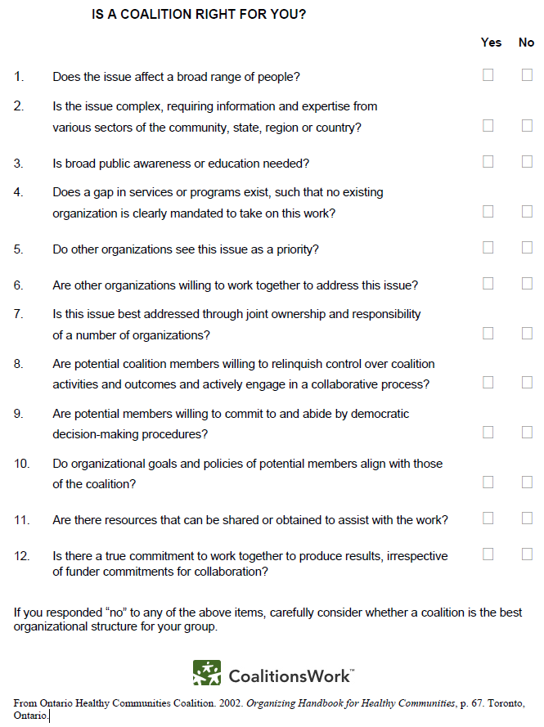

Lead Agencies
Characteristics
- Strong links to and respect for the local community

- Has respect of community organizations and key leaders and perception as neutral entity

- Understanding of community health issues, priority populations, and local politics

- Adoption within its own walls of positive health practices that support the activities of the coalition

- Ability to serve as an umbrella organization (501(c)(3))

- “Deep Pockets” or at least a reserve of resources to support the basic administrative needs of the coalition

- Staff support through employment and benefits structure

- Development, media, and advocacy capabilities to promote the coalition

Key Individuals and Organizations
- Leaders

- Administrative & Facilitators

- Champions

- Technical Experts

- Evaluation Experts

- Community Experts

- The problem

12 Sectors
- Youth and Young Adult - A person under 25

- Parent - Mother/father/guardian/grandparent

- Business - Chamber of Commerce/owner of local shop

- Media - The outlet where the majority of the community gets information

- School - Principal/Superintendent

- Youth-Serving Organization - Boys & Girls Club

- Law Enforcement - Chief of Police/Sheriff

- Religious/Fraternal Organizations - Pastor/Rabbi/Imam/Masons

- Civic/Volunteer Groups - Lions Club/Kiwanis Club, not just some random “volunteer” on the coalition

- Healthcare Professionals - Doctor/Nurse/Dentist

- State/Local/Tribal Government - Single State Agency/State Prevention or Treatment Director

- Other Substance Abuse Organization - Local prevention/treatment provider

Recruiting and Retaining Members
Process
- Assess member and resource needs

- Develop a long term strategy

- Make a plan

- Execute

Assessing Needs
Identify existing resources

Are the resources truly known?

Are existing resources being used?

Identify what is needed
- Skills
- Sectors
- Resources

Skill, Sector or Resource |  | Why is this needed? | Potential individual/organization | Who will contact them? | Why will this be important to them?

Retaining Members
6 “R”s of retaining members
- Recognition: Recognizing members both externally and internally regarding their contribution to a better quality of life
- Respect: Joining and supporting the organization should result in respect from other organizations and community members
- Role: Everyone must have a role, it gives individuals and organizations purpose.
- Relationship: People join to get connected and stay because they are connected to other businesses and organizations in the community
- Reward: The reward of being a member must outweigh the costs. Rewards may be both for the organization or the individual
- Results: If you don’t get results, people do not stick around. What are the results of the work your members are putting in?

Retaining Members Activity
Recognition
Respect
Role
Relationship
Reward
Results

New Member Packets
A new member packet is a packet of coalition materials given to new member that informs them about the coalition.

At a minimum, the packet should include:
- Commitment Letter
- CBO History
- Community data
- New Member Questionnaire

Other items may include:
- Welcome Letter
- Mission and Vision
- Skill and Interest Questionnaire
- Bylaws, policies, member expectation
- CBO Calendar
- Past Events
- CBO Partners
- Committees and Workgroups
- Most recent meeting minutes
- List of Board Members

Talking to Potential New Members
Elevator Speech-

Focused Conversation-

Developing Structures and Rules
SAMHSA on components of an effective coalition:
To be effective, coalitions require:
A strong and stable organizational structure that clarifies roles and procedures, and adequately addresses task and maintenance function

A formalized set of structures and practices, such as written roles and procedures (such as bylaws)

Management strategies that include effective communication, conflict resolution, perception of fairness, and shared decision-making

Organizational effectiveness is related to positive work climate, higher member satisfaction, better communication among committee members, stronger linkages with community organizations, and less conflict.

Effective leadership, opportunities for leadership development, and staff support are frequently identified as the most essential elements of an effective coalition.

Effective leaders are open, task-oriented, and supportive of the group.

Examples of Coalition Organization Charts
Organizational Structure
  - Typically hierarchal with executive committee and subcommittees (permanent and ad-hoc)
  - Staff may be placed adjacent or within the hierarchy

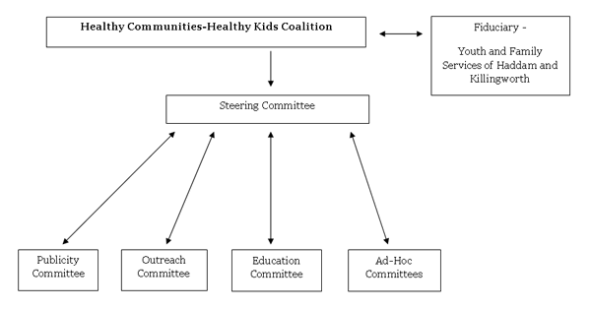
http://hc-hk.org/staff.html
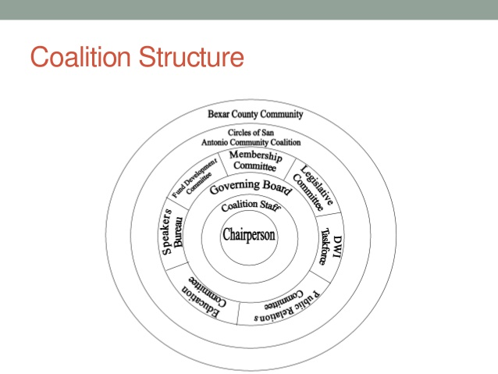
http://www.slideshare.net/CirclesofSA/coalition-orientation-for-sacada-board-members
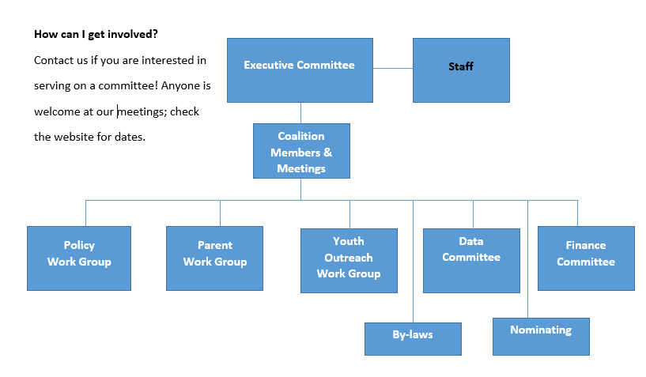
http://www.easthamptoncoalition.org/about-us.html

By-laws
Bylaws are used to:
Help organizations deal with new situations
Help organizations make decisions
Help organizations operate ethically
Bylaws are:
Formally written rules that control the internal operations of the organization
A document that formally defines the groups:
Official name
Purpose
Requirements for membership
Officer titles and responsibilities
How officers are assigned
How meetings are conducted
How decisions are made

Bylaws serve as the legal guidelines of an organization and the organization COULD BE CHALLENGED in court for its actions if it violates them.

Job Descriptions
Job Descriptions;
Define the position for the organization, potential applicants, and legally

Clarify duties

Make it clear when a member is not performing to standard

Will make it more likely that you will find the right person for the job

Job Descriptions have;
Title
Duties
Length of service in the position
Time required to fulfill duties
Background required (skills, education)
Reporting structure
Paid/Volunteer

Engaging Community Members
Community engagement refers to the process by which community benefit organizations and individuals build ongoing, permanent relationships for the purpose of applying a collective vision for the benefit of a community.
Tips:
- Be inclusive (Don’t just invite friends)

- Define useful roles

- Don’t meet for the sake of meeting!

- Rotate meeting locations and times

- Change format (informal, calls, surveys, independent work groups)

- Use electronic media effectively

Butterfoss, F. D. (2007). Coalitions and partnerships in community health. San Francisco, CA: Jossey-Bass.
Colorado Office of Behavioral Health (2015) Strategic Prevention Framework-Partnership for Success (SPF-PFS) Tookit 2015-2020. Retrieved from http://www.omniportal.org/BHPACDocuments/Substance%20Use%20Prevention%20Strategic%20 Prevention%20Framework%202015-2020.pdf
Butterfoss, F. D. (2007). Coalitions and partnerships in community health. San Francisco, CA: Jossey-Bass.
http://www.samhsa.gov/capt/tools-learning-resources/components-effective-coalition
http://ctb.ku.edu/en/table-of-contents/structure/organizational-structure/write-bylaws/main
http://www.healthypeople.gov/2010/state/toolkit/08Partners2002.pdf

